Practical no 1
Implementing advanced deep learning algorithms such as convolutional neural networks (CNNs) or recurrent neural networks (RNNs) using Python libraries like TensorFlow or PyTorch.
import numpy as np
import tensorflow as tf
from tensorflow.keras import layers, models
num_samples = 1000
image_height = 28
image_width = 28
num_channels = 3
X = np.random.rand(num_samples, image_height, image_width, num_channels)
y = np.random.randint(0, num_classes, size=(num_samples,))
train_size = int(0.8 * num_samples)
X_train, X_test = X[:train_size], X[train_size:]
y_train, y_test = y[:train_size], y[train_size:]
model = models.Sequential([
layers.Conv2D(32, (3, 3), activation='relu', input_shape=(image_height, image_width, num_channels)),
layers.MaxPooling2D(pool_size=(2, 2)),
layers.Conv2D(64, (3, 3), activation='relu'),
layers.MaxPooling2D(pool_size=(2, 2)),
layers.Flatten(),
layers.Dense(128, activation='relu'),
layers.Dense(num_classes, activation='softmax') # For 2 classes, softmax with sparse_categorical_crossentropy works
])
model.compile(optimizer='adam',
loss='sparse_categorical_crossentropy',
metrics=['accuracy'])
history = model.fit(X_train, y_train, epochs=10, batch_size=32, validation_data=(X_test, y_test))
test_loss, test_acc = model.evaluate(X_test, y_test)
print(f"\n Test accuracy: {test_acc:.4f}")
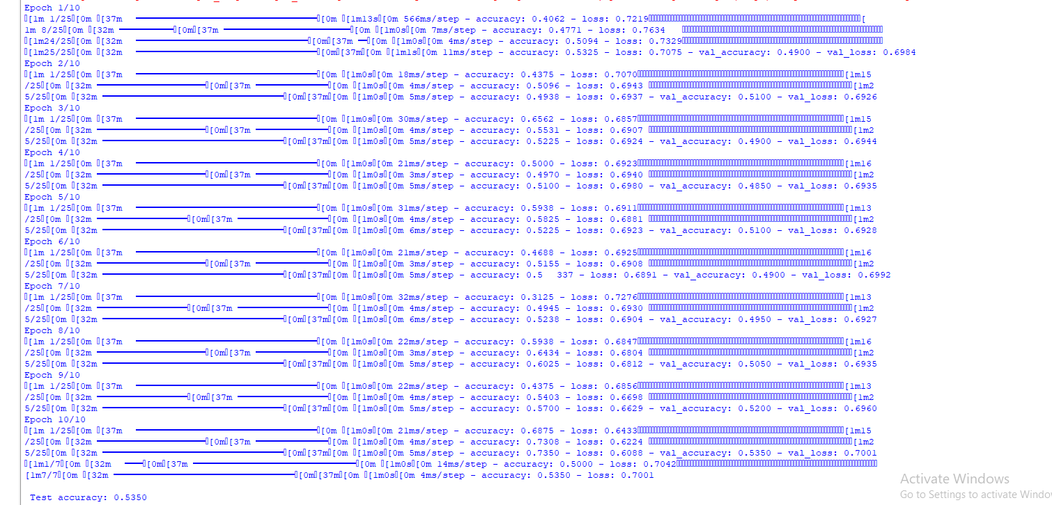
Output
Practical no 2
Building a natural language processing (NLP) model for sentiment analysis or text classification.
import pandas as pd
from sklearn.model_selection import train_test_split
from sklearn.feature_extraction.text import CountVectorizer
from sklearn.naive_bayes import MultinomialNB
from sklearn.metrics import accuracy_score, classification_report
data = { 'text': [
'I love this product, it is amazing!',
'This is the worst purchase I have ever made.',
'I am very happy with the service.',
'I will never buy from this store again.',
'The quality is excellent!',
'Terrible experience, very disappointed.',
'Absolutely fantastic! Highly recommend it.',
'Not good at all, I want a refund.',
'Very satisfied with my order.',
'The item broke after one use, awful.' ], 'label': ['positive', 'negative', 'positive', 'negative', 'positive', 'negative', 'positive',
'negative', 'positive', 'negative']
}
df = pd.DataFrame(data)
X_train, X_test, y_train, y_test = train_test_split( df['text'], df['label'], test_size=0.2, random_state=42, stratify=df['label']
)
vectorizer = CountVectorizer()
X_train_vectors = vectorizer.fit_transform(X_train)
X_test_vectors = vectorizer.transform(X_test)
model = MultinomialNB()
model.fit(X_train_vectors, y_train)
y_pred = model.predict(X_test_vectors)
accuracy = accuracy_score(y_test, y_pred)
print(f'Accuracy: {accuracy:.2f}')
print('Classification Report:')
print(classification_report(y_test, y_pred, zero_division=0))
custom_reviews = [
"This product exceeded my expectations!",
"Worst service ever, completely dissatisfied.",
"The experience was okay, not great, not terrible.",
"Highly recommend this to everyone!"
]
custom_review_vectors = vectorizer.transform(custom_reviews)
custom_predictions = model.predict(custom_review_vectors)
for review, sentiment in zip(custom_reviews, custom_predictions):
print(f"Review: \"{review}\" -> Sentiment: {sentiment}")

Output
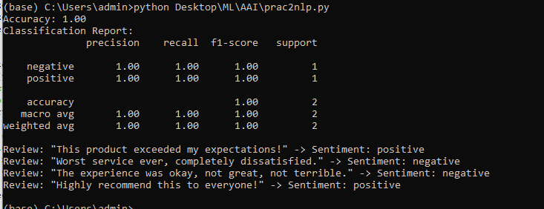

PRACTIAL NO 3
Creating a chatbot using advanced techniques like transformer models.
from transformers import GPT2LMHeadModel, GPT2Tokenizer
import torch
import os
os.environ["HF_HUB_DISABLE_SYMLINKS_WARNING"] = "1"
os.environ["HF_HOME"] = "./hf_cache"
model_name = "microsoft/DialoGPT-medium"
try:
model = GPT2LMHeadModel.from_pretrained(model_name, cache_dir="./hf_cache")
tokenizer = GPT2Tokenizer.from_pretrained(model_name, cache_dir="./hf_cache")
except Exception as e:
print(f"Error loading model: {e}")
exit()
def chat_with_bot(input_text):
try:
inputs = tokenizer.encode(input_text + tokenizer.eos_token, return_tensors="pt")
attention_mask = torch.ones(inputs.shape, dtype=torch.long)
outputs = model.generate(
inputs,
max_length=100,
pad_token_id=tokenizer.eos_token_id,
attention_mask=attention_mask,
no_repeat_ngram_size=2,
temperature=0.7,
top_p=0.9,
top_k=50,
do_sample=True,
)
response = tokenizer.decode(outputs[:, inputs.shape[-1]:][0], skip_special_tokens=True)
return filter_response(response)
except Exception as e:
return f"Error during response generation: {e}"
def filter_response(response):
response = response.strip()
if len(response) < 5:
return "Could you say that again? I'm not sure I understood."
return response
if __name__ == "__main__":
print("Chatbot: Hello! Type 'exit' to end the conversation.")
while True:
user_input = input("You: ")
if user_input.lower() == "exit":
print("Chatbot: Goodbye!")
break
response = chat_with_bot(user_input)
print(f"Chatbot: {response}").
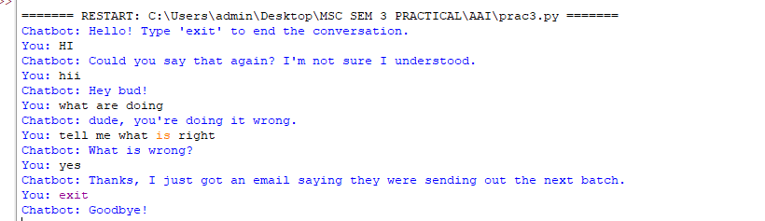
Output:

Practical 4
Aim- Developing a recommendation system using collaborative filtering or deep
learning approaches.
import pandas as pd
import numpy as np
from sklearn.decomposition import TruncatedSVD
data = {
"UserID": [1, 1, 2, 2, 3, 3, 4, 4, 5, 5],
"MovieID": [101, 102, 101, 103, 102, 103, 101, 104, 103, 104],
"Rating": [5, 4, 3, 4, 2, 5, 5, 3, 4, 2]
}
movies = {
"MovieID": [101, 102, 103, 104],
"Title": ["Dangal (2016)", "3 Idiots (2009)", "Chhichhore (2019)", "Lagaan (2001)"]
}
ratings = pd.DataFrame(data)
movies = pd.DataFrame(movies)
ratings = pd.merge(ratings, movies, on="MovieID")
user_item_matrix = ratings.pivot_table(index="UserID", columns="Title", values="Rating").fillna(0)
svd = TruncatedSVD(n_components=2) # 2 components for simplicity
user_factors = svd.fit_transform(user_item_matrix)
item_factors = svd.components_
predicted_ratings = np.dot(user_factors, item_factors)
min_rating, max_rating = predicted_ratings.min(), predicted_ratings.max()
predicted_ratings = 1 + 4 * (predicted_ratings - min_rating) / (max_rating - min_rating)
predicted_df = pd.DataFrame(predicted_ratings, index=user_item_matrix.index, columns=user_item_matrix.columns)
predicted_df = predicted_df.round()
print("Predicted Ratings (Scaled):\n", predicted_df)
def recommend_movies(user_id, user_item_matrix, predicted_df, top_n=3, threshold=2):
user_ratings = predicted_df.loc[user_id]
rated_movies = user_item_matrix.loc[user_id] > 0
recommendations = user_ratings[~rated_movies]
print(f"Predicted ratings for User {user_id}:\n", user_ratings)
recommendations = recommendations[recommendations > threshold].sort_values(ascending=False)
if recommendations.empty:
print("No recommendations above threshold. Returning top N highest-rated movies.")
recommendations = user_ratings.sort_values(ascending=False)
return recommendations.head(top_n)
recommendations = recommend_movies(1, user_item_matrix, predicted_df, top_n=3, threshold=2)
print("\nRecommended Movies for User 1 (High Ratings):\n", recommendations)
Output
